
Department of Mechanical Engineering

EMCH 368
MECHATRONICS

Lab 06
Serial Communication

Last Edited: 01/08/24 by J. Vaught

Processing is an open-source graphical library and integrated development environment (IDE) / playground built for the electronic arts, new media art, and visual design communities with the purpose of teaching non-programmers the fundamentals of computer programming in a visual context. Processing uses the Java language, but is very similar to the syntax and environment of Arduino, so you should feel comfortable coding in this software.

Exercise 1: Controlling Your Arduino Using the PC
So far we have been creating sketches on the computer, uploading them to the Arduino, and interacting with the Arduino to create outputs like turning on LEDs or playing a tone. In addition to that, we can also send live commands from the computer to the Arduino and vice versa! When you program your Arduino, you are opening up communications between the computer and the microcontroller. This form of communication is called “serial communication” in which your Arduino and PC are exchanging bits of information one after another. If you recall in previous experiments, we have used the Serial.begin() function to initiate the serial connection and to declare the number of bits per second to be communicated between the Arduino and PC.

Some other serial functions can be used to send information to the computer. Previously we have used Serial.print() to send information to the computer for us to read. Serial.print() is great if you want to view data collected by the Arduino because it converts your input to a string, converts the string to binary, sends it through the serial connection, and the binary bits are reinterpreted into the letters and/or numbers you specified. However, there is a command called Serial.write() which is used to send information to the computer for it to read and store. This information is sent in values between 0-255 as raw bytes to what’s called the serial buffer. Serial.write() is faster than print because there are less conversions taking place.

Whichever command you use, after the data is transmitted from either the Arduino or PC, it waits in the serial buffer until the receiving device is told to retrieve it. Note that the Arduino can only communicate serially to one device at a time, so while you are actively sending data to the serial buffer, you cannot also send data to the serial monitor. While this communication is running you also cannot upload new code to the Arduino.

Your goal is to create a circuit that meets the following criteria:
- Establish a serial communication between the Arduino and the PC
- Use Processing 3 to create a graphical user interface (GUI)
- The GUI should be programmed so that when the user clicks the left mouse button on the PC, an LED on the Arduino lights up
- On the GUI, whenever the user clicks the right mouse button, the LED turns off

Materials:
- 1 set of long red and black jumper wires
- 1 LED of any color
Building the Circuit:
- Connect the power and ground to the breadboard.
- Place an LED on the breadboard
- Connect the anode of the LED to digital pin 3
- Connect the cathode of the LED to ground with a 220 Ohm resistor
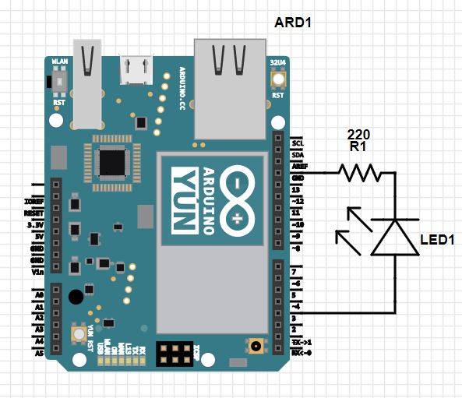
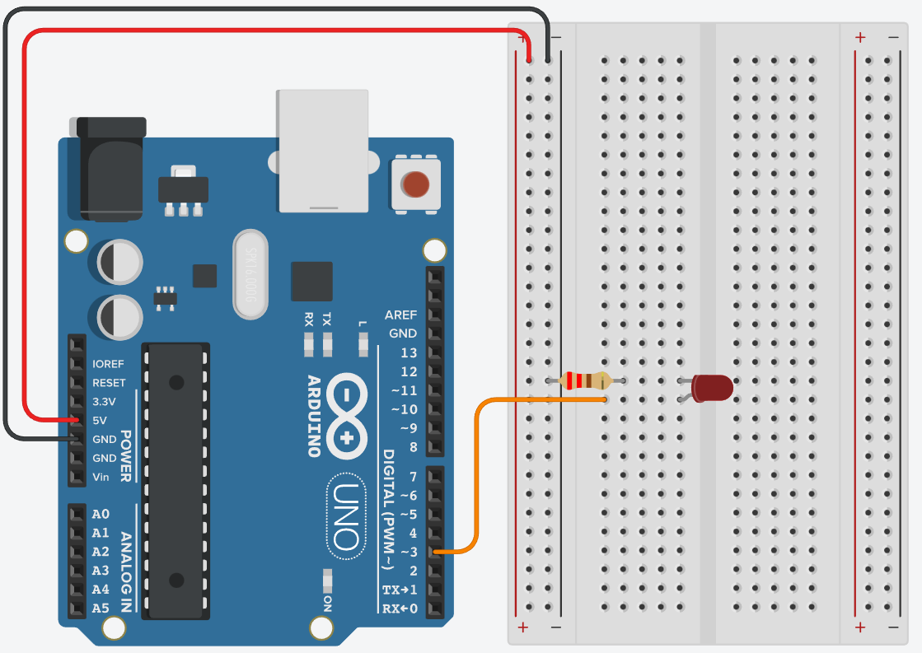
Exercise 1 Circuit
Writing the Program:

Arduino
For this lab, you will need to write code on two separate platforms: the Arduino IDE and the Processing IDE. First, we will utilize the Arduino IDE you are already familiar with to setup a serial connection between the Arduino and your PC.

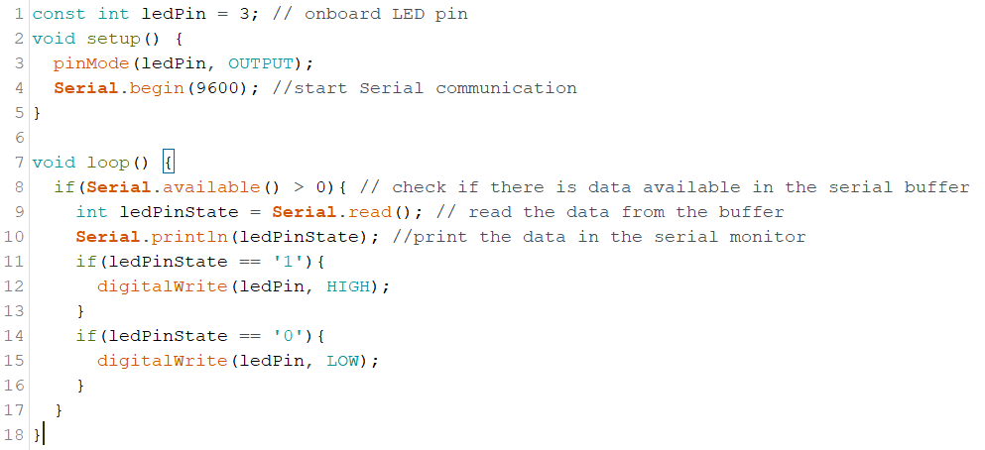

Begin by declaring a variable for the digital pin connected to the LED


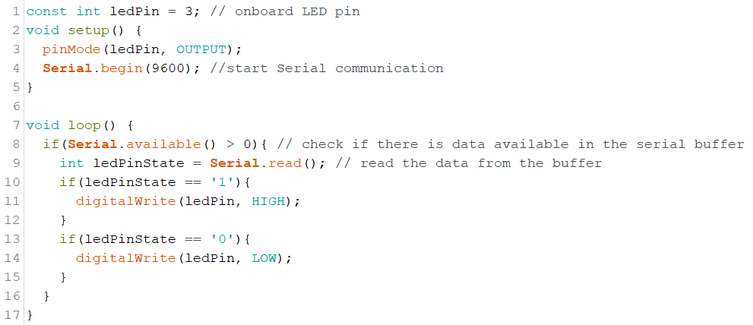
In the setup, set the led pin to an output and establish the serial connection between the Arduino and PC. So far this should be very familiar!

Begin the loop command by checking to see if the PC has sent any data to the serial buffer. Serial.available() will return how many discrete bytes of data are waiting in the buffer. If there IS data in the buffer, it will return a value greater than zero. If this is the case, we want to retrieve that data with Serial.read() and store it in a variable called ledPinState.



We want the Arduino to turn on the LED if the data it retrieved from the computer is 1. If it’s 0, turn the LED off. This is all the code we are going to write in the Arduino IDE. Next, we will use Processing 3 to create a GUI and somehow send a value of “1” whenever the left mouse button is pressed and a “0” whenever the right mouse button is pressed.

Processing 3

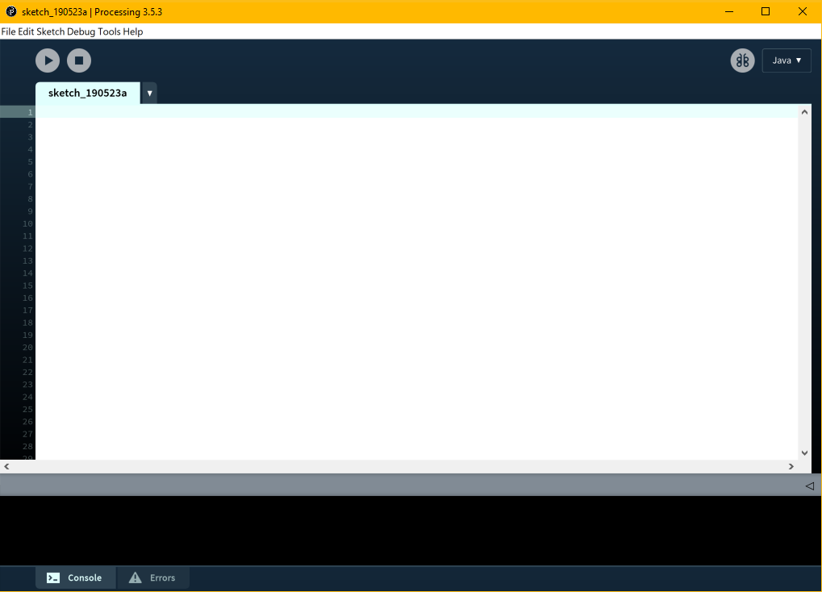

When you first open Processing it will look like the figure above. Processing is based on Java and Arduino’s programming environment is based on Processing’s so it should look pretty familiar to you.

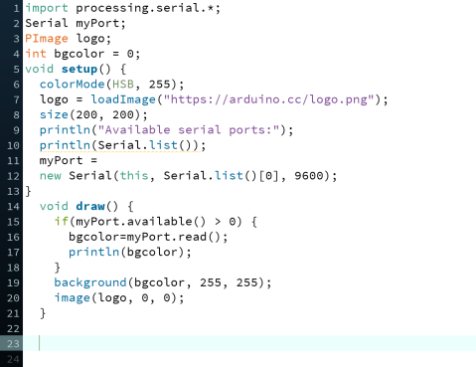

We will begin with importing the serial library. This is necessary because Processing does not know about serial ports without using an external library unlike the Arduino which has serial functions native to the IDE. You need to create an instance of the serial object, just like you’ve done in Arduino with the Servo library. You will use this uniquely named object whenever you want to use that serial connection.

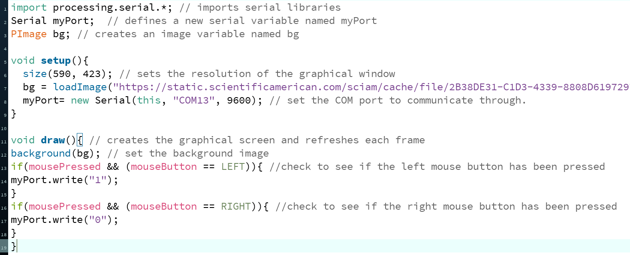

Create a PImage variable named bg (background). PImage is a data type that does not exist in Arduino but is a data type for storing images in Processing. Think about how an “int” data type is used to store integer numbers.


Just like in Arduino, we begin the program by using the setup() function. This is where we will open the serial connection and give the program some parameters to use while it is running.

First, let’s load an image into the variable bg. Go on google and find an image of an LED. This can be whatever image you want. Copy the image address and note the resolution of the image:
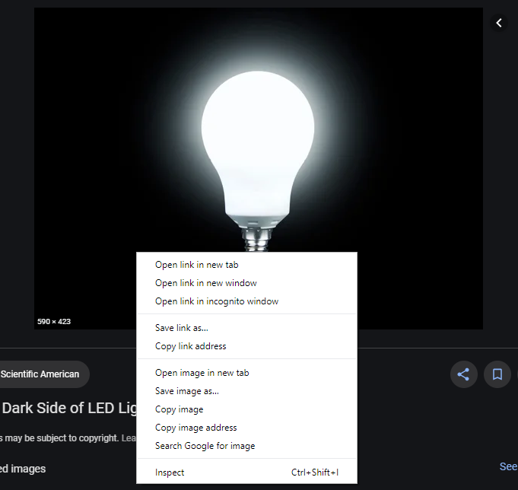

Within the setup command, specify the size of graphic window that will appear when you run the Processing code. The size of the window should be same resolution of your chosen photo.

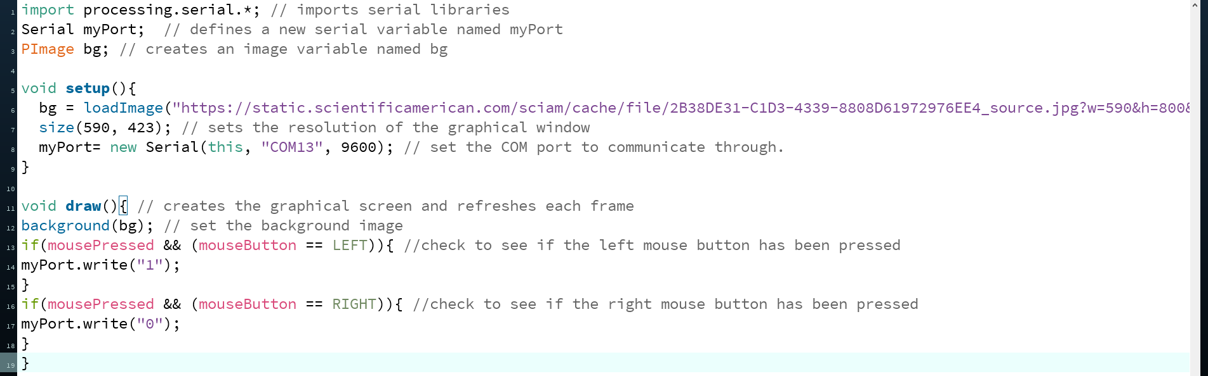

Now we can define the port. To do this we need to define the variable myPort that we created earlier. The parameters listed within the parenthesis are the application it will be speaking to (this), the serial port it will communicate over a specific COM port (although COM13 is listed above, you need to check which port your Arduino is actually connected to), and at what speed (9600).



The draw() function in Processing is very similar to the loop() function in Arduino. This is where the main part of the code is written.




Set the background of the graphical window with the image of the LED we found earlier.
Now, we need to program the computer to output a “1” when the left mouse button is pressed and a “0” when the right button is pressed. The variable mousePressed is set to 0 when no button is pressed and is automatically set to LEFT, RIGHT, or CENTER depending on which button is pressed. When the left button is pressed, use myPort.write(“1”) to send a 1 into the serial buffer. Similarly, set up the right mouse button.

Using the Circuit:
Now that you have your circuit constructed and your program written, you are ready to use it! Plug in the circuit like you have done before and run the Arduino code. This begins the serial communication by telling the Arduino what to read and how to report it. Once the Arduino code is successfully run, switch to Processing and run the code. If it displays an error like the one below, select the COM port that matches with the port listed under “Tools” in Arduino. Once you have the correct reference listed, you should be able to turn the LED on and off using the mouse.
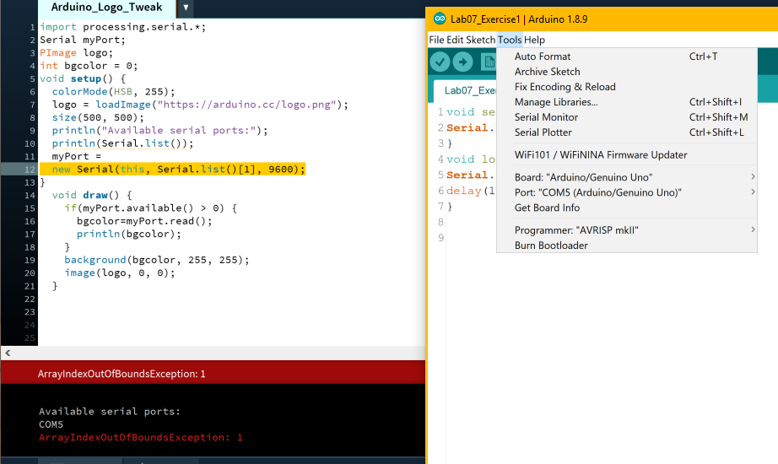
Exercise 2: Controlling Your PC Using the Arduino
In this exercise, you will do another simple circuit. However, this time you will have the user interact with the Arduino board to produce a response on the PC.

Your goal is to create a circuit that meets the following criteria:
- Uses a potentiometer to vary the voltage read by an analog pin
- Establishes a serial connection between the Arduino and PC so that the Arduino sends values to the serial buffer and the PC retrieves them
- Use Processing 3 to retrieve data from the serial buffer
- Use the voltage value from the Arduino as an input to change the background color of the Arduino logo on the PC using the Processing 3 software. The image file of the logo can be found with the link given below in the code explanation
Materials:
- 1 set of long red and black jumper wires
- Potentiometer and knob
Building the Circuit:
- Connect the power and ground to the breadboard.
- Connect the end pins of the potentiometer to power and ground.
- Connect the middle pin of the potentiometer to analog pin A0.
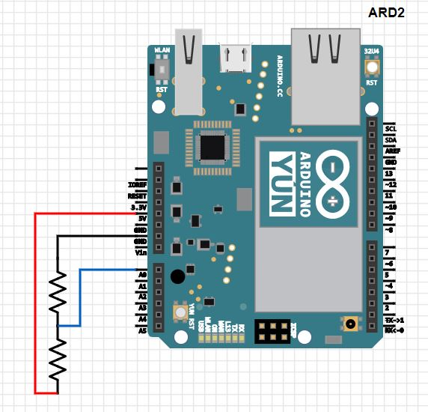

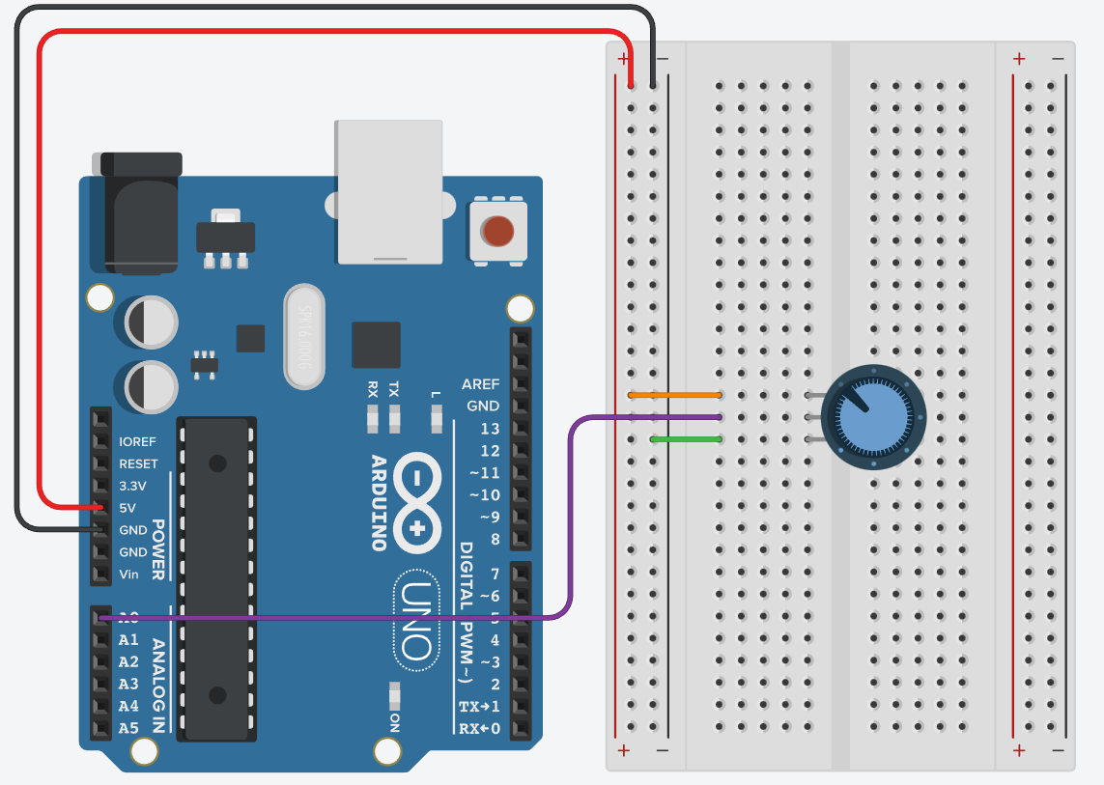
Exercise 2 Circuit
Writing the Program:

Arduino
Start by opening the serial connection using Serial.begin().

In the loop() function we will use Serial.write() to send information using the serial connection. The Arduino’s ADC produces a value from 0-1023, but Serial.write can only send values between 0 and 255. We can achieve this by dividing the initial analog value by 4.

To complete the code, include a delay to tell the computer to wait 100 milliseconds after sending a byte. If this number is set too low and communication is happening too quickly, the PC will not have time to interpret the bytes as it receives them.

Processing 3


Like in the last exercise, import the serial library and create a Serial variable.


Create a variable to store the Arduino logo and a variable to store a value for the background color. Since the logo is a .png file and has built-in transparency, it is possible to change the background color.


In the setup command, we need to set the color mode. Typically, Processing works with colors in a Red Green Blue (RGB) fashion. In this project, we are going to use the color mode HSB which stands for Hue, Saturation, and Brightness. We adjust the hue as the potentiometer on the Arduino is turned. colorMode() includes two arguments: first is the type of mode and the second is the maximum expected value.


Now we need to load the image for the logo. Simply provide the URL of the image and Processing will download it when you run the program. Use the size() function to tell Processing how large the display window should be. In this case, we will use the arbitrary value of 200 wide by 200 high. Feel free to increase or decrease these dimensions.


Define the port as we did in the previous exercise.



Within draw() we want to instruct Processing to read the data from the Arduino serial port. It begins by checking to see if there is information available from the Arduino. The available() function determines if there is information in the serial buffer. If there is data available, the value will be input into the bgcolor variable and println() will print it in the debug window at the bottom of the screen (similar to the Serial Monitor on Arduino).



Finally, the image background color can be set and displayed. The color is set using the background() function which defines the color of the window using three arguments. Since we only want to change the hue, only the first argument is based on the data sent by the Arduino. The brightness and saturation are both set to the maximum value. Then tell the program to display the image using image(). This function requires three arguments: what to draw, the initial x coordinate, and the initial y coordinate (use 0,0 to indicate the top left).

Using the Circuit:

Once the Arduino code is successfully run, switch to Processing and run the code and run that too. A window with the Arduino logo should appear on your computer. You should be able to change the color of the Arduino logo background with just a twist of the potentiometer.

Exercise 3: Create your own video game and controller

Now that you have an idea of how the Arduino and computer can interact, let’s dive deeper. You will be developing your own video game programmed in Processing 3 as well as designing a controller with an Arduino circuit. Your video game will be very basic, but hopefully it will serve as an introduction to how to start integrating hardware and software design.
The controller will consist of four pushbuttons create a resistor ladder. The circuit will actually be the exact same one we used in the keyboard instrument lab. However, we will orient the buttons the breadboard so that they look more akin to a real video game controller.
Before diving in, there’s a few conventions you need to know of graphics-oriented programming. The coordinate system has x and y directions, and each unit along an axis is one pixel. The origin (0,0) of the drawing is usually considered to be the top-left corner of the window. The positive x-direction is to the right, as you might intuitive expect, but the positive y-direction is downwards. For example, the point (100, 200) is 100 pixels to the right of the origin, and 200 pixels below the origin.
Also, whenever a shape is drawn in Processing, its origin is also at the top left of the shape. For example, if you tell Processing to draw a rectangle at point (100,200) the upper left corner will be at the point.

Your goal is to create a video game and controller that meet the following criteria:
- In the game, you control a square named Steve that can move up, down, left, and right
- Another, smaller square that we will call the food will appear in a random location in the game window
- Whenever the large square moves over the food, the food is “eaten.” As in, the food should disappear and reappear at another random location in the game window.
- The large square must be bound within the game window and cannot move outside of it
- Design an Arduino circuit that includes an up, down, left, and right push button that corresponds to the direction that the large square moves in your game
- Use a resistor ladder so that only one variable is sent through the serial

Materials
- 1 set of long red and black jumper wires
- 4 pushbutton switches
- 1 220-ohm resistor
- 2 10-kilohm resistors
- 1 megohm resistor

Building the Circuit:
- Remove USB power before tampering with the circuit
- Remove all components besides the power and ground supply. Wire the two (+) power buses across the breadboard.
- Place four buttons in a + orientation as seen below. These will be our “left”, “up”, “right” and “down” buttons respectively going clockwise. Note that the left-button and right-button do not cross the gap of the breadboard. Make sure the bends of the switches’ pins point outward to the left and right to ensure that when the switch is open, there is no electricity flowing between the two different rows of the breadboard.
- Wire the bottom side of the left switch to power
- Connect the left side of the up-button to power using a 220-ohm resistor. Wire the top side of the left-button to the right side of the up-button. This allows current to either pass through the left switch and bypass the top switch, or to pass through the top switch if it is closed while the left switch is open.
- Connect the top side of the right button to power with a 10-kilohm resistor. Connect the right side of the up-button to the bottom side of the right-button. Note that the wire may need to run to a pinhole underneath the right-button.
- Connect the right side of the down-button to power with a 1-megaohm resistor. Wire the bottom side of the right-button to the left side of the down-button.
- Connect the junction of the left side of the down-button to analog pin A0. Also ground it with a 10-kilohm resistor

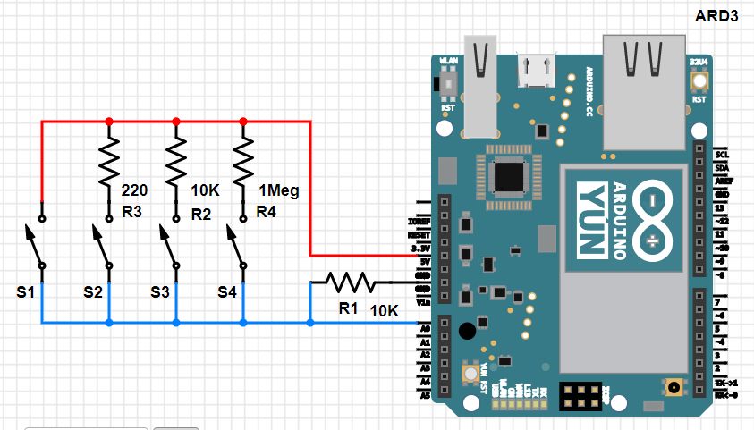

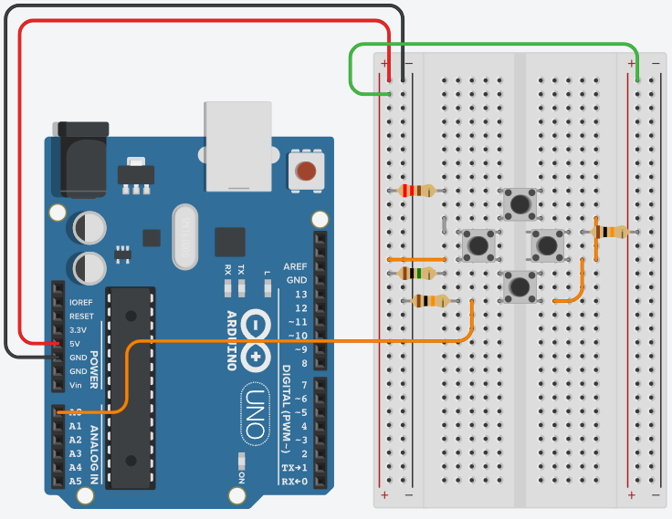
Exercise 3 circuit
Writing the Program:
Arduino

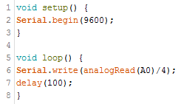
Starting with the Arduino code, we will use the exact same program as in the previous exercise. Begin the serial connection at 9600 baum, and have the Arduino send data to the computer every 100 milliseconds.

Processing 3
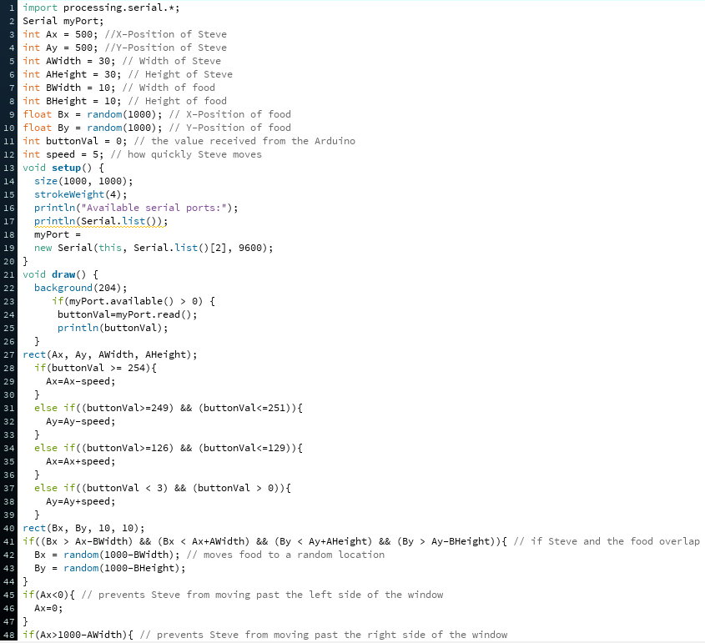

Import the serial library in the Processing 3 IDE. Name your Serial myPort.
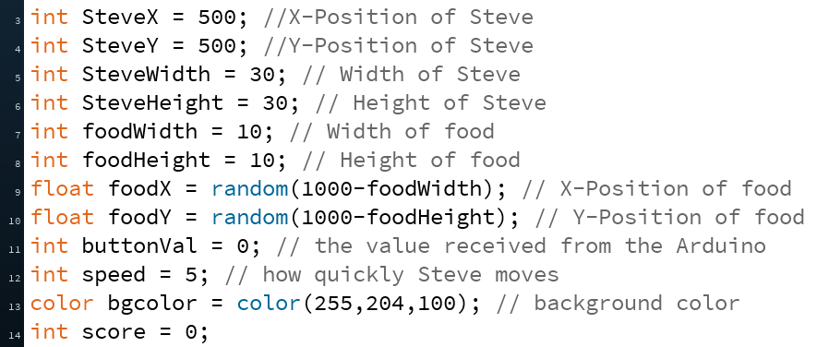
Similar to Arduino, at the beginning of your code you should declare the variables you plan to use throughout the program. The variables we will need for our video game include the dimensions of Steve, the position of Steve, the dimensions of the food, the position of the food, the variable buttonVal where we will store the data we receive from the Arduino, and the speed at which Steve moves. You can also set the color of the background which is stored in a datatype called color. The combination of rgb values shown above creates a yellow, but feel free to experiment with these values to get the color you want!

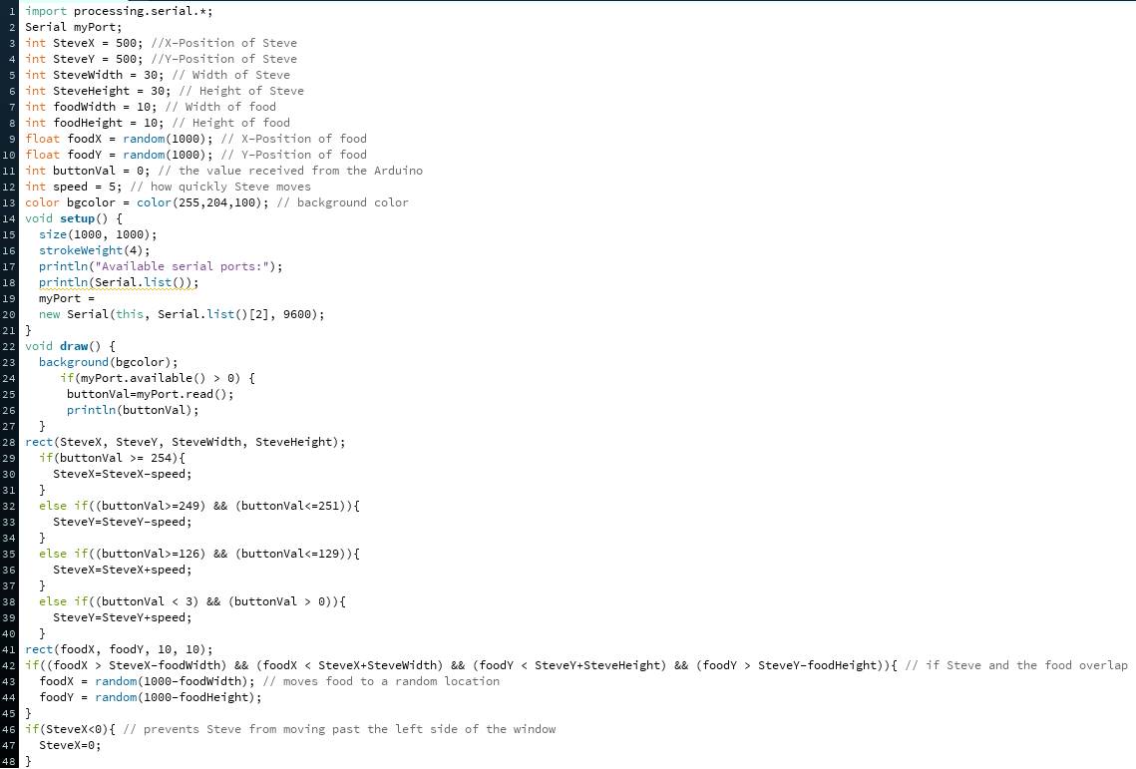

In setup(), define the size of the game window and the stroke weight with which Steve and the food will be drawn. Like in the last exercise, check which Serial ports are available. Hit the play button with the code as-is that you have a list of the available serial ports.



Define myPort with the Serial() function as we did before.



At the start of the draw() function, tell the program what color to make the background. The number 204 will create a gray background.



Next check if there is any data in the serial buffer. buttonVal will store the data coming from the Arduino. Print out buttonVal so that it appears in the output window at the bottom of the screen while the code runs.
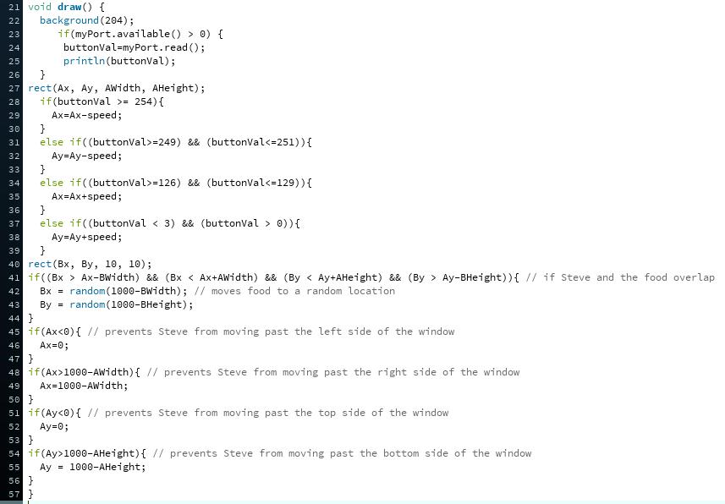

Draw the square that will be Steve. When we run the program, he will begin at whatever values of x and y you initialized at the beginning of the code in lines 3 and 4.



You might remember that when you did the keyboard instrument lab, as you pushed different keys, the Arduino read a different voltage. You then set up a series of if() statements that told the piezo to play a certain note if the voltage fell within a certain range. To get Steve to move, use the value you receive from the Arduino buttons, buttonVal to determine which button was pressed.
For example, when the left button is pressed, the current should flow straight into digital pin A0 without going through a resistor so the ADC should read 1023 which translates to 255 once it reaches Processing. Whenever buttonVal is 255 (or close to it), make Steve move left. To do this, update his x position by subtracting his speed from it. The higher the speed, the more Steve will move to the left when the next frame is drawn.
Note that because the positive y-direction is downwards, whenever you want Steve to move up (by clicking the up button) you will actually want to subtract from his y-position and vice versa.


Draw the food. It will be displayed as a smaller rectangle that begins at the random x and y coordinates that you initialized in lines 9 and 10.

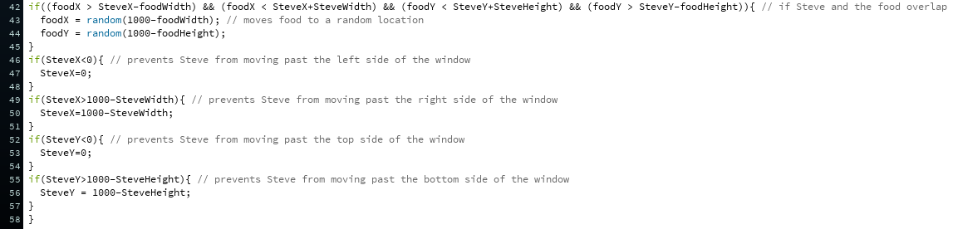

This block of code is what checks to see if Steve has reached the food. The if statement checks if the boundaries of the food have crossed inside the boundaries of Steve, and if so, the food is moved to another randomized location.

Finally, set some boundaries so that Steve cannot move off of the game window. For example, if Steve tries to move off of the left side of the screen, his x-coordinate would become less than zero. Whenever this happens, set his x-coordinate equal to zero and it will appear as if there is a wall that he cannot move through.

Use the circuit:
Begin by plugging in the Arduino and uploading the Arduino code. When this is finished, start your Processing program. A window should appear similar to this:
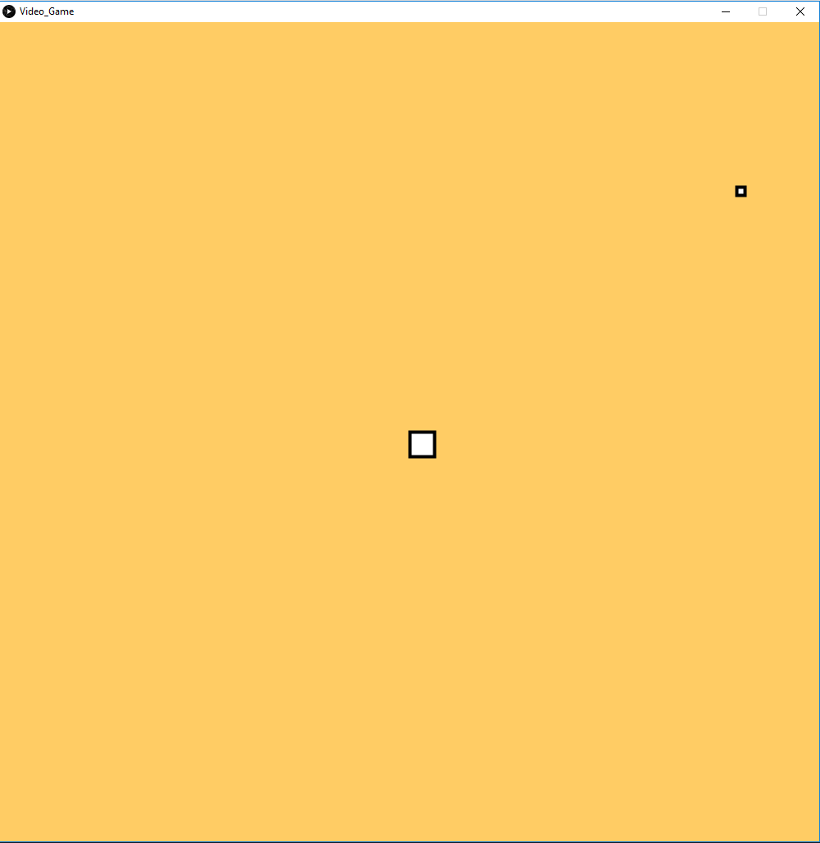
Try pressing each of the buttons on your Arduino controller to make sure they work. You should see Steve, the bigger square begin moving around the screen! If Steve has stuttered movements, buttonVal may be fluctuating and you may need to adjust the conditions of your if() statements.
Try running out of bounds. Does Steve stop on the edge of the game window?
Try running over the food. It should immediately disappear and reappear somewhere else in the window.

Create a scoreboard:

This time, you’re on your own! Using the code you’ve already written as well as functions you find at https://processing.org/reference/, design a scoreboard that counts up one every time Steve eats a piece of food. Display the score in the top-left hand side of the game.

Lab 06 Code Appendix (in order of appearance)
Processing 3 Code:

Import - used to load a library into a Processing sketch

PImage - Datatype for storing images. Processing can display .gif, .jpg, .tga, and .png images

colorMode(mode, max) - Changes the way Processing interprets color data. By default, the mode is RGB. The max denotes the maximum value that can be expected as an input

loadImage(filename) - Loads an image into a variable of type PImage.

size(x, y) - Defines the dimension of the display window width and height in units of pixels

println() - writes to the console area, the black rectangle at the bottom of the Processing environment.

Serial(Program, Serial Port, Speed) - Sets up the computer to begin reading from the serial port. Specify the program you are using the serial connection for, the serial port, and the communication speed. This speed should be the same speed you specify in the Arduino code of Serial.begin().

background(color) - sets the color used for the background of the Processing window. The default background is light gray.

image(PImage, x-pos, y-pos) - draws an image to the display window and specifies the position of the top left corner of the image

color - a datatype found in Processing but not in Arduino that stores color values

color(red, green, blue) - creates a color value based on the levels of red, green, and blue that you specify.

strokeWeight(pixels) - Sets the width of the stroke used for lines, points, and the border around shapes. All widths are set in units of pixels

textSize(height) - sets the size of the font, measured in pixels.

text(text/number, x-pos, y-pos) - displays text or number

fill(red, green, blue) - defines the color that the subsequent text and shapes are filled with

rect(x-pos, y-pos, width, height) - draws a rectangle on the screen. The upper left corner of the rectangle is placed at the specified x and y positions
Lab 6 Grading Rubric:
- Exercise 3 Circuit fully built. (15 points)
- A working scoreboard added to exercise 3 (5 points)
- Exercise #1 works/adequately answer questions about circuit #1 (10 points)
- Exercise #2 works/adequately answer questions about circuit #2 (10 points)
- Exercise #3 works/adequately answer questions about circuit #3 (10 points)
Grade distribution template (total 50 points)
- 20 points for built, but not working exercise 3 circuit.
- Exercise grade = (30 points/# of exercises) * (0, 0.5, 1) = zero, half or full exercise grade.

